Mapping the current knowledge in syndemic research applied to Men who have Sex with Men : a Scoping Review

Maxence R. Ouafik1, Laetitia Buret2, Jean-Luc Belche3, Beatrice Scholtes4

1 Corresponding author at : General Practice Department - Primary Care and Health Research Unit, MD - PhD student, University of Liège, Liège, Belgium [maxence.ouafik@uliege.be](mailto:maxence.ouafik@uliege.be) ; Quartier Hôpital B23 Avenue Hippocrate 13 4000 Liège OrcID <https://orcid.org/0000-0002-9795-5721>

2 General Practice Department - Primary Care and Health Research Unit, MD - GP - PhD, research assistant, University of Liège, Liège, Belgium [laetitia.buret@uliege.be](mailto:laetitia.buret@uliege.be) OrcID <https://orcid.org/0000-0001-6039-9824>

3 General Practice Department - Primary Care and Health Research Unit, MD - GP - PhD, lecturer, University of Liège, Liège, Belgium [jlbelche@uliege.be](mailto:jlbelche@uliege.be) OrcID <https://orcid.org/0000-0001-8807-0473>

4 General Practice Department - Primary Care and Health Research Unit, Postdoctoral Researcher, University of Liège, Liège, Belgium [beatrice.scholtes@uliege.be](mailto:beatrice.scholtes@uliege.be) OrcID <https://orcid.org/0000-0001-5274-822X>

# 1 Results

## 1.1 Literature search

The electronic search identified 769 citations and our handsearch of reference lists resulted in the addition of the seminal study by Stall and colleague[1] . After duplicates removal, 277 unique references were left to be screened for inclusion.

Among these references, 109 were excluded after reading the title and abstract. The two main reasons for exclusion at this stage were that MSM were not the main population of the study (n=46) or that syndemic was not the main focus of the paper (n=34). 29 additional studies were excluded because the type of publication did not meet our inclusion criteria.

The full texts of the 168 remaining references were obtained and read, which lead to the exclusion of 59 citations. During the previous step, we decided to include papers in which the sample was not entirely comprised of MSM. After reading the full paper, we opted to exclude the studies if the MSM data was aggregated with data from another population (n=9), most commonly transgender women. The rationale for this decision was to keep the focus clearly on MSM.

The PRISMA flowchart generated by DistillerSR can be found in Figure 1.1

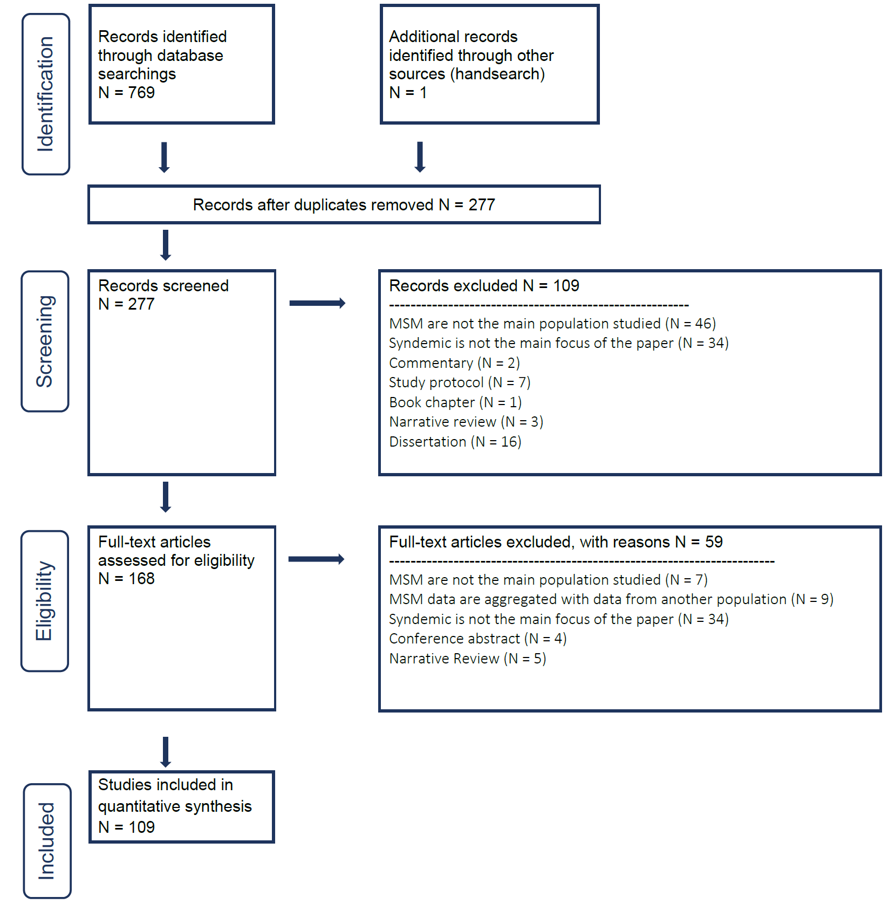

Figure 1.1: PRISMA flowchart of the included search strategy

## 1.2 How are studies concerning Syndemic Theory applied to MSM conducted?

### 1.2.1 General characteristics of included studies

The publication date of the studies range from 2003 to 2021 with a marked increase in the number papers published yearly from 2013 onward as illustrated in 1.2. Apart from the quantitative increase in the number of studies, there’s also a qualitative increase in the diversity of the studies, both in the type of design used and the countries where the studies are conducted.

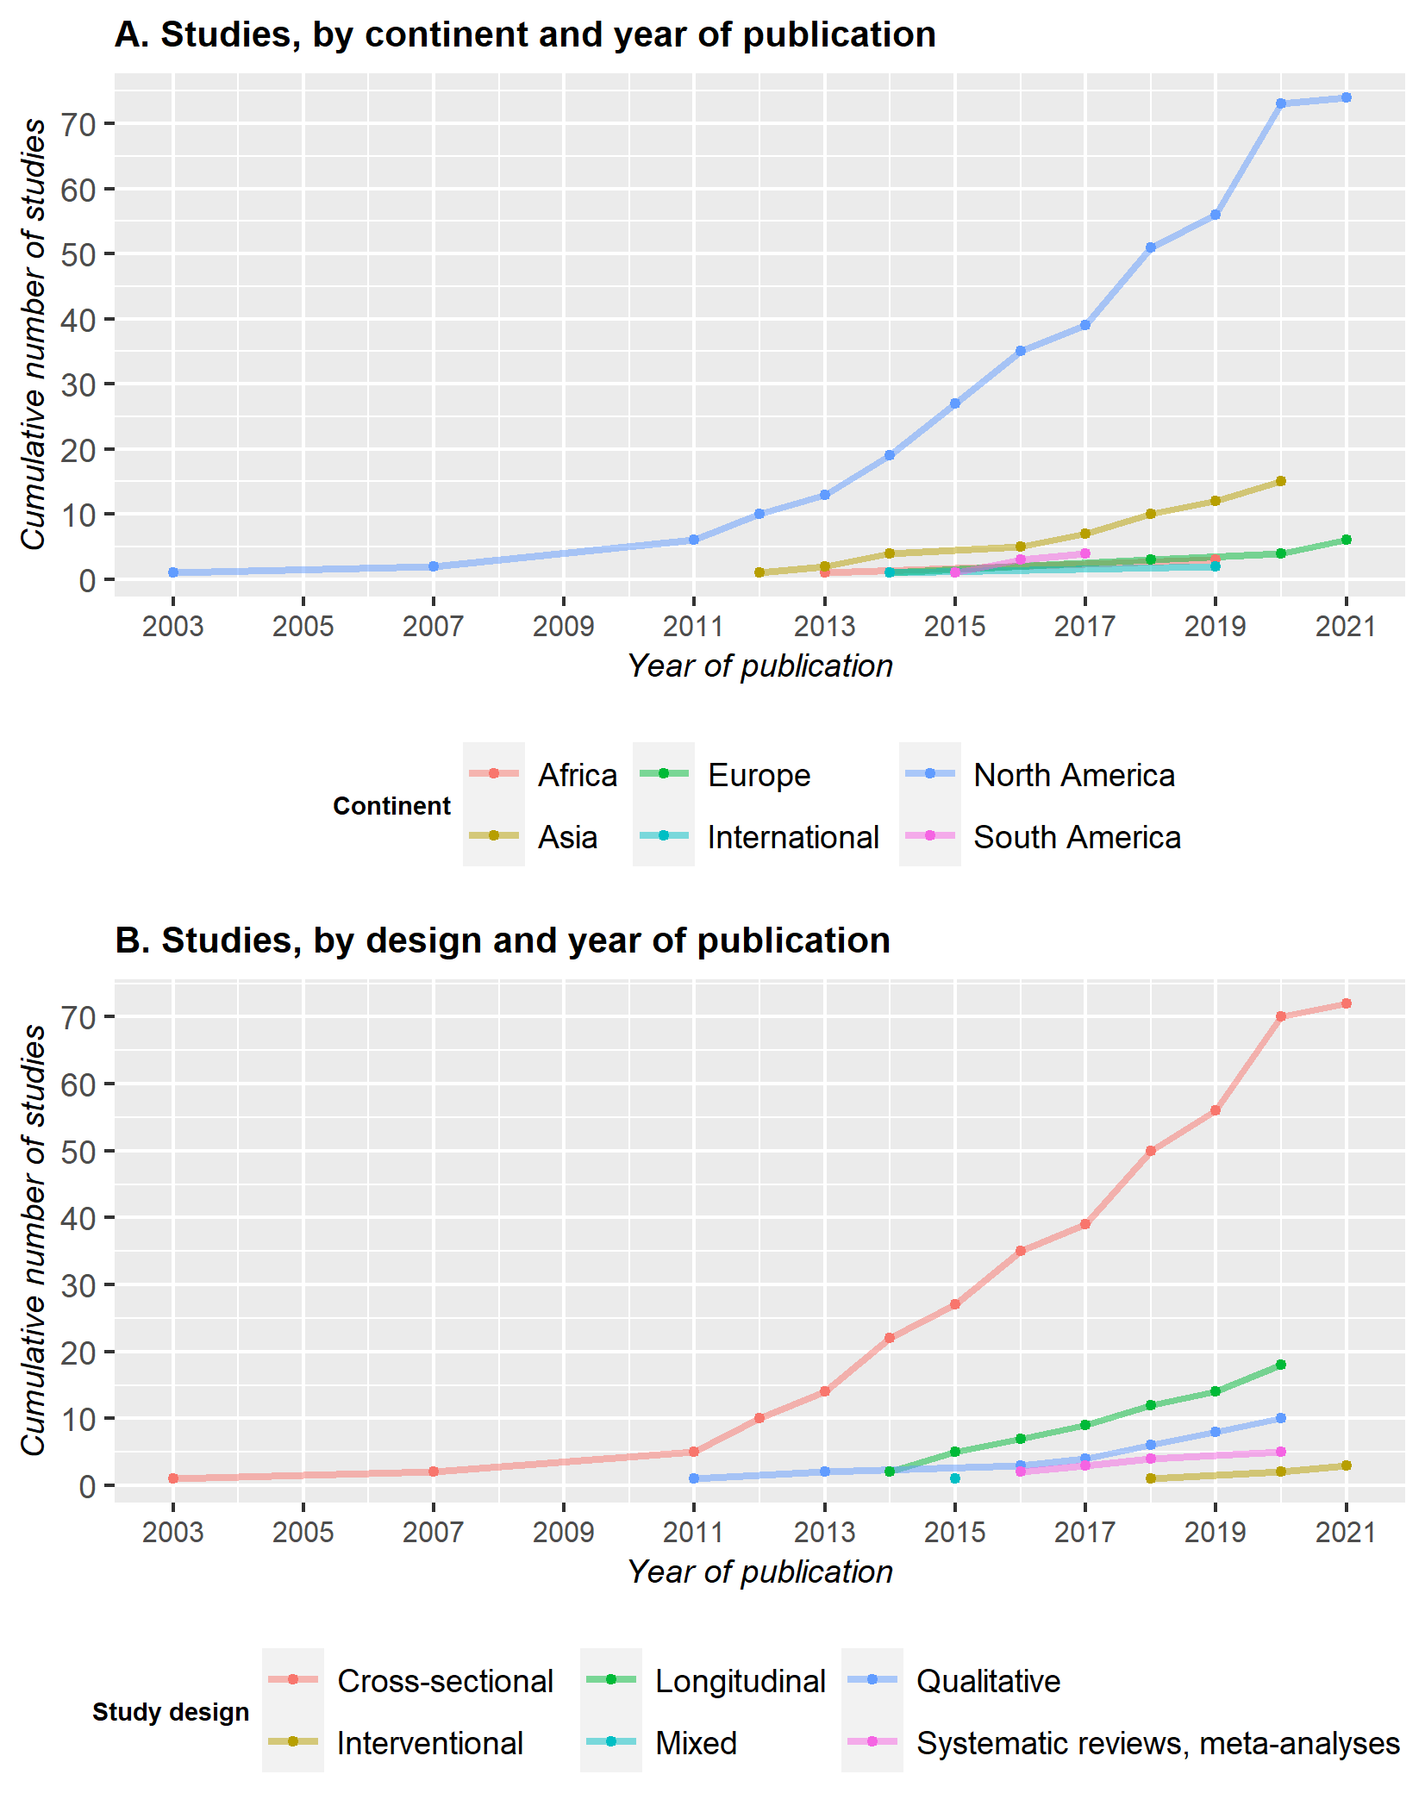

Figure 1.2: Plot of the cumulative number of studies published yearly, grouped by continent (A) and design (B)

However, despite this growing diversity, the vast majority of studies are conducted in North America (N = 74), with a large predominance of studies in the United States of America (N= 62). The majority of the remaining studies were then located in Asia (N = 15) or in Europe (N = 6). South America and Africa were the least represented continents, with only 4 and 3 studies respectively.

In terms of design, a similar pattern appears, with most of the studies employing a cross-sectional design (N = 72). The number of longitudinal studies steadily grew since 2014 but only represents 17% of the papers to this day. Qualitative studies are also under-represented, with only 10 papers. Of note, we only identified 1 mixed design[2] ; this study employed a cross-sectional design for the quantitative part and in-depth interviews analyzed through grounded theory for the qualitative part. The first systematic reviews and meta-analyses were published recently, in 2016 while the first interventional studies were published in 2018.

Finally, the median sample size of the studies was 450 (range : 15 - 24 274) and the mean age of the participants, when reported ranged from 16 to 57.89.

### 1.2.2 Subpopulations studied

### 1.2.3 Syndemic conditions and their measurement

### 1.2.4 Outcomes and their measurement

### 1.2.5 Interventions

## 1.3 How is the concept of interaction explored in syndemic research applied to MSM?

### 1.3.1 Statistics used to show an interaction

### 1.3.2 Proposed mechanisms of interaction

## 1.4 What were the key findings of these studies?

# 2 Discussion

# 3 Conclusion

# 4 References

1 Stall R, Mills TC, Williamson J, *et al.* Association of co-occurring psychosocial health problems and increased vulnerability to HIV/AIDS among urban men who have sex with men. *American Journal of Public Health* 2003;**93**:939–42. doi:[10.2105/AJPH.93.6.939](https://doi.org/10.2105/AJPH.93.6.939)

2 Buttram ME, Kurtz SP. A mixed methods study of health and social disparities among substance-using african american/black men who have sex with men. *Journal of Racial and Ethnic Health Disparities* 2015;**2**:1–0. doi:[10.1007/s40615-014-0042-2](https://doi.org/10.1007/s40615-014-0042-2)